Contact: Bob Richter at bob@richterdesign.net | 212 802 8588
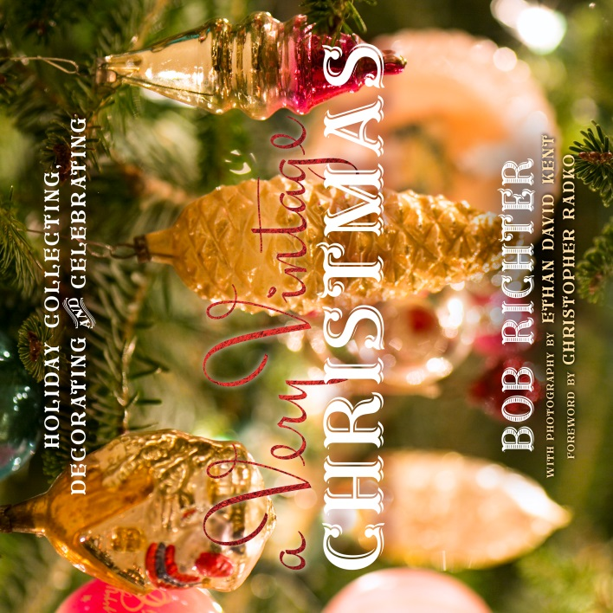
New Book Illustrates How to Collect, Decorate, Entertain, Gift and Preserve Vintage Christmas

A Very Vintage Christmas:
Holiday Collecting, Decorating and Celebrating
By Bob Richter
With Photography by Ethan David Kent
Foreword by Christopher Radko

Praise for A Very Vintage Christmas:

“This mirthful book shows us how Bob makes magic with vintage Christmas, and it’s a joy to read. Bob connects the past with the present, and breathes life into the whole picture... Bob’s discovered that you can take anything old, and make it new and relevant to your life again.” – Christopher Radko

“Christmases past come alive through Richter’s nostalgic assortment of bottle-brush wreaths, spun-glass garlands and bisque Santas.” FIVE STARS - Entertainment Weekly

“Learn to make old things new and entertain the vintage way with this full-color tribute to Christmases of old. Each chapter celebrates a unique component of an old-fashioned Yuletide, from ornaments to gift-wrapping, with tips for curating your very own throwback holiday.” - Parade Magazine

“Learn the best way to achieve vintage décor this season.” - Victorian Homes

“…A beautiful trip down memory lane to a place where the world was safe and everything was good.” FIVE STARS – For The Love of Books

Globe Pequot is proud to present A Very Vintage Christmas: Holiday Collecting, Decorating and Celebrating, by Bob Richter, (978-1-4930-2214-4, $24.95 hardcover, 8” x 8”, 224 pages, 300+ images).

Vintage Ornaments, lights, decorations, cards, and wrapping all conjure up happy memories of Christmases past and serve as tangible mementos of holidays shared with family and friends. Finding these objects, decorating with them, and sharing them with others brings an instant feeling of comfort and joy. A Very Vintage Christmas offers a 360-degree look at holiday décor in America and gives suggestions on how to make vintage finds work at home. While each chapter is unique, there are common threads that run through them all: nostalgia, sentimentality, preservation, and a love of beautiful holiday decoration. The book includes chapters on:

- Christmas Decorating History
- Finding Vintage Christmas
- Ornaments
- Lights
- Outdoor Décor
- Decorating with Vintage Christmas Items
- Decorating with No Tree
- Giving a Vintage Gift
- Cards, Wrapping, Tags, and Other Ephemera
- Entertaining the Vintage Way
- Storing and Preserving Your Vintage Holiday Finds
(over, please)

About the author: Bob Richter’s passion for collecting holiday décor began as a boy. One day his father, who would take him to auctions, handed Bob a box of beautiful ornaments, including a blue jay, a Santa Claus, some bells, and other special figures, and said, “It’s time you started collecting something and I know you like Christmas.” So collect he did—and still does. That original box has grown into a collection that hovers at around 2,500 and counting.

Regularly featured in media outlets including the New York Times, Entertainment Weekly, The Huffington Post, The Associated Press, Redbook, the Boston Globe, FOX, CBS, ABC, and HGTV, Bob delights in sharing antiques, design, and bargaining advice. As “The Designer” and breakout star of the PBS series Market Warriors, Bob uses his personality and expertise to strike deals at flea markets all over the country and he remains a fan favorite. He also hosts Flea Market Minute and Minute Makeover. As a correspondent for The Huffington Post, he writes for the Home, Style, Travel, and Arts sections. He is also a Tastemaker for “Vintage and Market Finds” on the high-end shopping portal One Kings Lane where he curates special sales with art, antiques, and rescued objects. Specializing in a marriage of comfort and smart design, Bob offers up a fresh take on living with “stuff.” His tongue-in-cheek mantra, “More is More,” speaks to his love of art and antiques, which he culls from around the globe. As a contributor to PBS.org, Bob has profiled Pop Artist Peter Max, written about art pottery, WWII collecting, vintage clothing, and more. He has also served as Guest Editor of NYCArts and offers antiques advice in eHow and The Intelligent Collector.

About Globe Pequot: Globe Pequot (globepequot.com) is the trade division of Rowman & Littlefield. Our flagship imprint celebrates all things local, creating books that appeal to visitors and residents alike. Our authors are leading experts on the people, places, food, art, culture and craftsmanship of the regions they cover.

A Very Vintage Christmas: Holiday Collecting, Decorating and Celebrating
Pages: 224 • Size: 8 x 8
978-1-4930-2214-4 • Hardback • July 2016 • $24.95
978-1-4930-2213-7 • eBook • July 2016 • $23.99
Distributed to the trade by National Book Network: 800-462-6420
For media inquiries: Bob Richter , 212-802-8588 or bob@richterdesign.net
# # #

